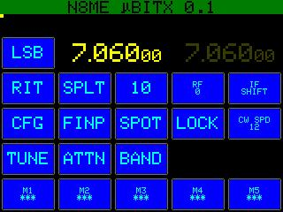

**N8ME µBITX Firmware**  
**User’s Manual**  
December 12, 2020

Revised December 13, 2022  
Mark Erbaugh, N8ME  
Alpha (0.2) Release

# License

This is a project I undertook to increase my Arduino programming skills. The source code is released under the [MIT license](https://opensource.org/licenses/MIT). The code uses a small amount of code directly from the stock µBITX 6.0 [firmware](https://github.com/afarhan/ubitxv6) which is licensed under [GNU General Public License v3.0](https://www.gnu.org/licenses/gpl-3.0.en.html). The code uses the [PDQ GFX](https://github.com/XarkLabs/PDQ_GFX_Libs) library which is licensed under the MIT license.

I hope that my findings will contribute to the development of the µBITX project.

Feel free to use my code in your own projects. Please understand that I will not be liable for any issues caused by the use and/or misuse of my code.

Please feel free to contact me with questions or issues that you discover. The preferred method of contact is via the [BITX Forum](https://groups.io/g/BITX20) on groups.io so that others can provide input and benefit from the discussion.

# User’s Manual

This is a work in progress and the software is designed to be modified. The operation and screen appearance may change so they may not be exactly as described.

This firmware was designed to work with the stock µBITX 6 hardware. It does not rely on nor support any other hardware, but its design may make incorporation of additional hardware easier. Since this software is designed to work with the stock hardware all the hardware operating concerns apply. Before transmitting be sure that the SWR is low enough to not damage the final transistors. As the radio produces RF energy, practice RF safety.

## User I/O

Inputs consists of the touch screen, the rotary encoder tuning knob and its push button, the PTT button on the microphone and paddles.

Output consists of the LCD screen and the speaker.

The software distinguishes between a short (tap) and long (hold) press of a touchscreen button. If the touch is held for about a second, the speaker will emit a short beep. All touch screen buttons respond to a touch. Some buttons have a secondary function activated by a hold.

The software can also distinguish between a short (tap) and long (hold) press of the rotary encoder (tuning knob) push button switch. If the push button is held for more than about a second, the speaker will emit a short beep.

# Main Screen



**VFO digits:** The radio supports VFO A (left) and VFO B (right). The user selects the primary VFO by tapping the frequency display digits. The secondary VFO frequency display will be dimmer than the primary one. The color of the VFO changes between transmit and receive. Holding the VFO frequency display will set the other VFO to be the same as the held VFO.

**LSB (mode):** Tap to toggle between CW and SSB. Hold to toggle between USB and LSB. The button text will change to indicate the mode: CWL, LSB, CWU or USB.

**BAND:** Tap to display the band selection screen (see description below).

**SPLT (split):** Tap to toggle split mode. In split mode, transmit will be on the secondary VFO.

**10 (tuning step):** This determines how much the VFO frequency and RIT change with each step of the tuning encoder. Tap to cycle through the tuning steps: 10, 20, 50, 100, 200, 500, 1K, 2K, 5K, 10K, and back to 10. Hold this button to reset to 10. The adjustable tuning step is in lieu of having acceleration (momentum) on the tuning knob.

**ATTN (attenuation):** Tap to toggle receive attenuation. The button highlights to indicate the attenuation is applied.

**TUNE:** Tap to emit a carrier for tuning. Tap again to stop. This works in both SSB and CW modes. As there is no way in software to change the level of the carrier, on the configuration screen, the carrier is pulsed with a user selected duty cycle (see the Configuration screen below).

**CFG:** Displays the configuration screen (see below).

**FINP (Frequency Input):** Displays the frequency input screen (see below).

**SPOT:** *CW mode only*, tap to turn on the sidetone as a tuning aid. Tune until the received signal and sidetone frequency match. Tap again or push the tuning knob to turn off the spot tone

**LOCK:** Tap to engage a frequency lock. The button highlights to indicate the lock. Tap again to unlock.

**CW SPD (cw speed):** *CW mode only,* tap to enter iambic paddle speed selection in WPM. The left VFO display will be replaced with the current CW speed. Rotate the tuning knob to adjust and tap the button or the tuning knob to select. The selected speed is displayed on the button.

**SHFT (shift):** Tap to engage the BFO shift. This adjustment is temporary and is added to the main BFO calibration. It may help improve signal clarity. The left VFO display will be replaced with the current value. Rotate the tuning knob to select adjust and tap the button or the tuning knob to select. The adjustment will stay until changed or the radio is turned off. Hold the button or the tuning knob to reset the shift to zero. The shift value is not saved to EEPROM. The radio will power up with a zero shift.

**RIT (receive incremental tuning):** Tap to engage RIT. In RIT mode, the RIT button will highlight and the tuning knob will adjust the receive frequency, but not the transmit frequency. Tap the button or the tuning knob to disable RIT. The RIT offset is retained and if RIT is reengaged that shift is applied. Hold the button or the tuning knob to zero out the RIT shift. The RIT offset is not saved to EEPROM. The radio will power up with a RIT offset.

# Band Selection Screen

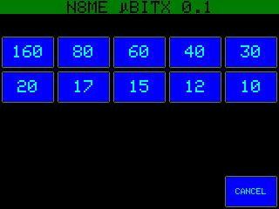

**80 through 10:** Select a frequency within the desired band. If the active VFO frequency is inside an amateur band, the new frequency will be in a proportional location in the new band (except on 10, where the location will be proportional to the lower 700 kHz of the band). Upon selection, the main screen is redisplayed.

**MW:** Select a frequency in the Medium Wave (AM broadcast) band. The step size is set to 10 kHz and the mode is set to LSB. Upon selection, the main screen is redisplayed.

**Cancel:** Return to the main screen without changing frequency.

# Frequency Entry Screen

## 

Use the numeric keys to enter a frequency in kHz. The entered digits are displayed in the gray area at the top. Tap the KHZ button to select a frequency and return to the main screen. Tap the <- button to erase the rightmost digit. Tap the CANCEL button to return to the main screen without changing the frequency.

# Configuration Screen

# 

**CANCEL:** Tap to return to the main screen discarding any changes (except the TX Enable/Disable state).

**SAVE:** Tap to return to the main screen, saving any changes. The SAVE will also save the VFO settings, such that the radio will return to those VFO settings when powered back on.

**CW PTCH:** the current CW pitch (sidetone) is displayed in the gray area. Rotate the tuning knob to adjust. The sidetone is activated and changes pitch as this is adjusted. Tap the CW PITCH button or the tuning knob to exit the CW PITCH setup.

**KEYER:** Tap the button to cycle through the possible KEYER modes: Iambic A, Iambic B and Hand (or straight key). In Hand Key mode, either paddle can be used as well as the microphone PTT button.

**PADDLE:** Tap to reverse the DIT and DAH paddles for iambic keying.

**TOUCH CAL:** Tap to display a touch screen calibration screen. A cross is displayed near one corner of the screen. Tap the center of the cross and another cross is displayed near the next corner. Once all four corners have been tapped the calibration is made (it isn’t actually saved until you press the SAVE button). Alternatively, press the tuning knob switch to abort the calibration process.

**TUNE PWR:** Tap to adjust the tune output power. The value is displayed in the gray area and can is adjusted with the tuning knob. Tap the TUNE PWR button again to exit the adjustment. This adjusts the duty cycle of the pulsed tuning carrier.

**DELAY:** Adjust the amount of time (in msec) the radio will remain in transmit mode after the last CW keying input. The current value is displayed in the gray area. Rotate the tuning knob to adjust. Tap the DELAY button or the tuning knob to enter a new value.

**FREQ CAL:** This adjusts the master frequency calibration. The calibration process is the same as with the stock firmware. On the main screen, tune the radio to the desired reference frequency. Then on this screen, tap the FREQ CAL button and adjust until the station is received properly. Tap the FREQ CAL or tuning knob to exit the adjustment. While adjusting the calibration is displayed in the gray area. See below on using WSJT-X for frequency calibration.

**BFO CAL:** Tap toe adjust the BFO offset. The calibration process is the same as with the stock firmware. Tap to enter the calibration mode and adjust the tuning knob until the noise “pedestal” is centered within the bars on the online tuning aid. The adjustment value is displayed in the gray area.

**TX DISABLE:** When this is active, the final transmit stage is not activated.

# Heartbeat Indication

A small yellow square at the left side of the screen immediately below the green banner flashes at a 1 Hz rate. This indicates that the radio software hasn’t hung up. It can be used to troubleshoot lockups (this is alpha software, after all).

## CAT Operation

The radio is designed to emulate a Yaesu FT-817 via the USB connection. The serial settings are 38400, N, 8, 1. The CAT operation has been tested (briefly) and works with FLDIGI, WSJT-X and N3FJP’s Amateur Contact Log. Note the N3FJP program places the radio in LOCK mode which can be undone with the main screen LOCK button.

A small light blue square immediately below the heartbeat indication flashes when CAT commands are received.

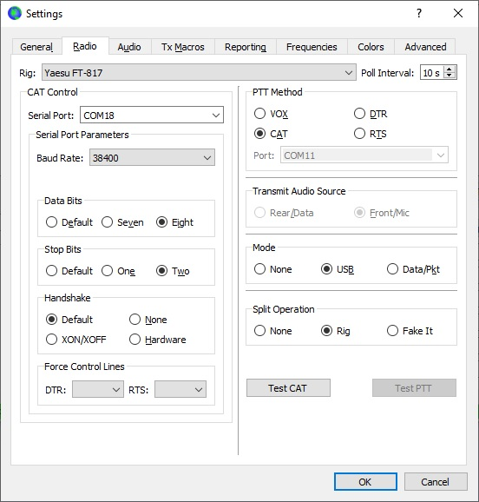

WSJT-X CAT Setup

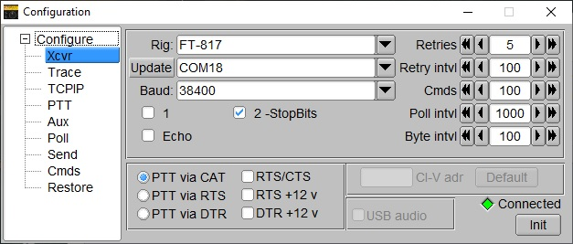

FLRIG CAT Setup

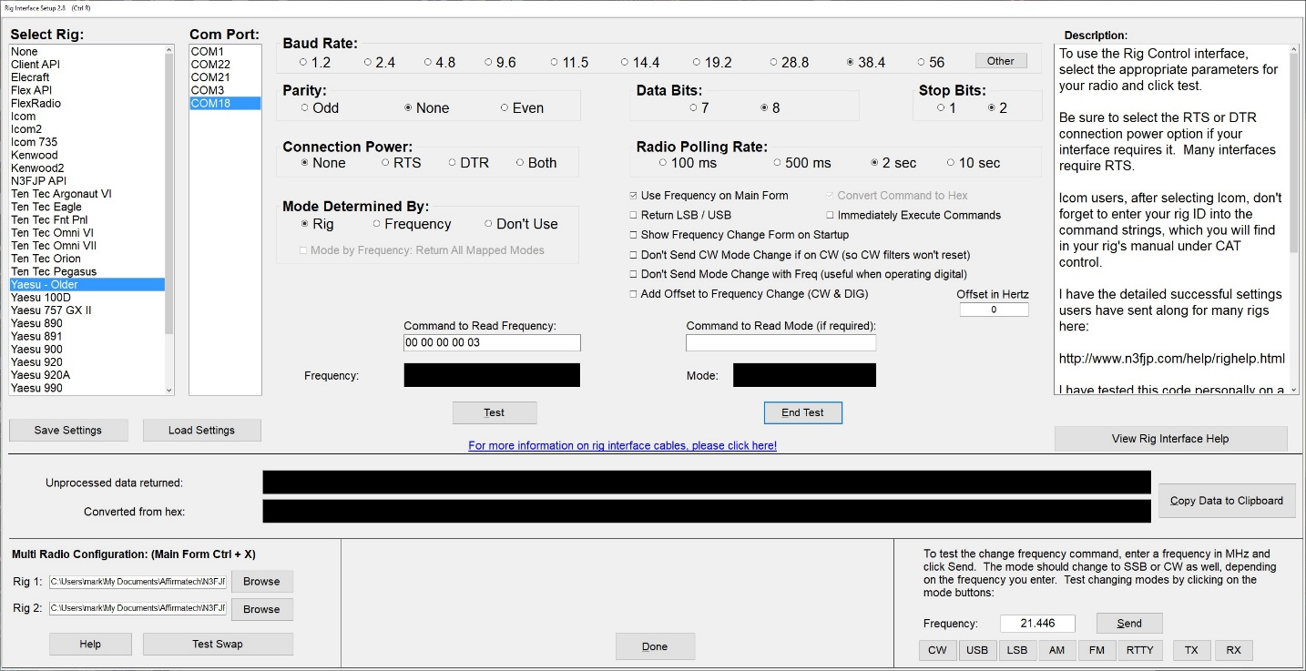

N3FJP Amateur Contact Log CAT Setup

# Calibration using WSJT-X

WSJT-X has a FreqCal mode. To use it tune to 1.5 kHz below the frequency of a stable AM (mode, not necessarily band) signal. WSJT will display the frequency of the AM carrier. On the CFG screen, tap the FREQ CAL button. Adjust the tuning knob until the observed carrier is at 1500 Hz, and the error (6th column in the log display) is as close to zero as possible.

